Revelation 7, 1/18/2019

Opening
- How long had you known your girlfriend/boyfriend before getting married? Have you heard a very romantic story in the Old Testament about Jacob (or Israel)?
  - How long had he waited to marry his sweetheart?
  - How many wives did he finally have? Why? Four.
  - Did they get along well? What happened?
- How many sons did Jacob have? Twelve.
  - Who was the firstborn? Reuben.
  - Do you know the prestige of firstborn in a Jewish family? Did Reuben keep his firstborn right? What happened? Then who became the firstborn? Joseph.
  - David and Jesus came out from whom? Judah. Why?
- All the twelve and their descendants are God’s chosen people. How are they related to Christians?
- Do you remember what we studied last time? ESV Study Bible.
  - The vision of the Lamb’s receiving the scroll (4:1–5:14) introduces a series of seven visions as the scroll’s seals are broken. These visions introduce instruments employed by the Lamb to bring his enemies to justice (seals 1–4, symbolizing conquering, war, famine and death), the rationale for his righteous wrath (seals 5 and 7), and the climax of judgment at history’s end (seal 6, similar to the description of Matthew 24). At the end of Chapter 6, there was a question “Fall on us and hide us from the face of him who is seated on the throne, and from the wrath of the Lamb, for the great day of their wrath has come, and who can stand?”
- What happens in Chapter 7? Opening the 7th seal? No. Rather, this Chapter answers the question raised at the end of Chapter 6. Read the Bible Revelation 7.

The 144,000 of Israel Sealed (7:1-8)
- Rev. 7:1–17 Interlude: The announcement of the seventh seal is delayed while the saints receive assurance that God knows them and protects them in the midst of the calamities depicted in Chapter 6. Reformation Study Bible.
- Rev. 7:1–3 The sixth seal (6:12–17) showed an earthquake and a wind that shook the stars from the sky. God’s cringing enemies asked, “Who can stand?” (6:17). The answer is, those “sealed” (7:4) with the seal of the living God (cf. Ezek. 9:4–6). Therefore John sees four angels charged to hold back those winds of judgment until all of God’s servants have received his seal. “The seal of the living God” evokes a picture of a royal signet ring by which kings authenticated documents or marked ownership of an item. This seal is the name of the Lamb and of God (Rev. 14:1), a gift promised to all who conquer by faith (3:12). It is antithetical to the mark of the beast (13:16) and symbolizes God’s ownership and protection of his people. Circumcision functioned as such a seal under the old covenant (Rom. 4:11), and God’s Holy Spirit seals God’s people as his property under the new (Eph. 1:13–14). Foreheads. Cf. Ezek. 9:4–6 for a similar instance of sealing God’s people against outpoured judgment. ESV Study Bible.
  - He called with a loud voice to “the four angels” who had been given power to harm earth and sea. The four angels mentioned in verse 1.
  - Ephesian 1:13–14. In him you also, when you heard the word of truth, the gospel of your salvation, and believed in him, were sealed with the promised Holy Spirit, who is the guarantee of our inheritance until we acquire possession of it, to the praise of his glory.
  - Ezekiel 9:4-5. And the Lord said to him, “Pass through the city, through Jerusalem, and put a mark on the foreheads of the men who sigh and groan over all the abominations that are committed in it.” And to the others he said in my hearing, “Pass through the city after him, and strike. Your eye shall not spare, and you shall show no pity.
- Rev. 7:4 144,000. Some find here a reference to members of actual Jewish tribes, the faithful Jewish remnant of the “great tribulation” (v. 14). Others take the passage as symbolic of all the faithful believers who live during the period of tribulation. NIV Study Bible.
  - The “servants of our God” in v. 3 must include gentile saints. Reformation Study Bible.
- How many sons did Jacob have? Can you briefly describe them?
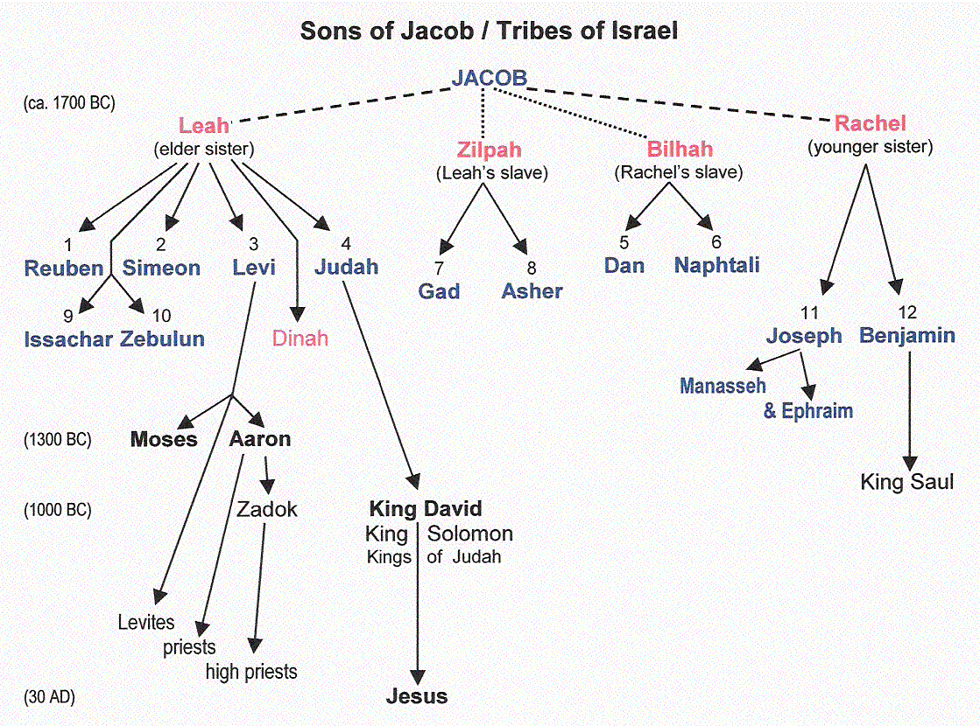
http://prophetess.lstc.edu/~rklein/Doc8/Family%20of%20Abraham_files/Israel.gif

- Rev. 7:4–8 These are not Jacob’s sons, for Dan is omitted and Manasseh included. They are not the tribes that inherited land in Canaan, for Dan is omitted, Levi (the priestly tribe) is included, and Joseph is listed instead of his son Ephraim. Judah, the tribe of the Messiah (5:5), appears first rather than Reuben, the firstborn. When 7:5–8 is compared with the list of Jacob’s sons in Gen. 35:22–26, the promotion of tribes descended from concubines Bilhah and Zilpah (Gad, Asher, Naphtali) over the sons of Leah and Rachel suggests that those once excluded from privilege are now included. The number 144,000 (12 x 12 x 1,000) suggests symbolism here. ESV Study Bible.
  - Genesis 49:8-10. Judah, your brothers shall praise you; your hand shall be on the neck of your enemies; your father's sons shall bow down before you. Judah is a lion's cub; from the prey, my son, you have gone up. He stooped down; he crouched as a lion and as a lioness; who dares rouse him? The scepter shall not depart from Judah, nor the ruler's staff from between his feet, until tribute comes to him; and to him shall be the obedience of the peoples.
  - Omissions of Dan and Ephraim: 1 King 12:28-33.
- Discussion
  - Do we have “seals” of God? Do we have a new life washed in the blood of the Lamb? Characterized by what?

A Great Multitude from Every Nation (7:9-17)
- Rev. 7:9 Great multitude. Identified in v. 14 as those who have come out of the great tribulation from all nations, tribes, peoples and languages. Palm branches. Used for festival occasions. NIV Study Bible.
  - Many who hold to a pretribulation “rapture” of the church think that the two groups of 7:1–8 and 7:9–17 are different (converted Jewish people still suffering on earth in vv. 1–8, but the raptured church rejoicing in heaven in vv. 9–17). Others think these are Gentiles converted during the tribulation through the witness of the 144,000 Jewish believers who remain on earth (v. 4). Those who do not hold to a pretribulation rapture usually see vv. 1–8 and vv. 9–17 as the same group, with their suffering in vv. 1–8 turned to joy and reward in vv. 9–17. ESV Study Bible.
- Rev. 7:13–14 An elder identifies the multitude as the ones coming out of the great tribulation. Some understand the definite article (Gk. hē, “the”) to refer to one great final period of suffering, but others take this to represent the sufferings of the church throughout all history. ESV Study Bible.
- Rev. 7:15–17 The sufferings on earth of those mentioned in vv. 13–14 are left behind, showing that John now reflects on the future heavenly inheritance. They hunger no more, neither thirst anymore. As priests, they serve God in his temple, in which he will shelter them from sun and scorching heat (cf. Isa. 49:10), spreading his tent over them and “dwelling” with them (cf. Ezek. 37:27; John 1:14). Under the protective care of the Lamb, their shepherd, they find refreshment in springs of living water (Ps. 23:1–2), tasting the promised joys of the new Jerusalem even before its final descent from heaven (Rev. 22:1), their every tear dried by God himself (Isa. 25:8; Rev. 21:4). Such comfort gives martyrs and other deceased believers rest as they await their resurrection and their persecutors’ destruction (6:11; 14:13). ESV Study Bible.
- Discussion
  - Do you ever praise God and Jesus? How should we praise them? Can we learn from this chapter?
  - Have you ever thought that we ourselves are God’s priests, and we need to serve Him and serve people?
  - What do you think about vv. 15-17? Are they beautiful?

Wrapping up
- What are your favorite verses in this chapter? Why?
- Want to find out what happened when the seventh seal was opened? Next Friday.

Peter Luh, David Tai and Chunlong Liu, 1/16/2019
Peter Luh, Chunlong Liu, Koh Han Siew, Xiao Zhou, and Yu Ji, 5/8/2014
Copyright UCBSG, UConn Chinese Bible Study Group, 2014 and 2019

