Revelation 6, 1/11/2019

Opening
- Compared with our parents and grandparents, are we a lucky generation? What kinds of disastrous events have we gone through? How about our parents and grandparents?
  - How about our children and grandchildren – perhaps a little too early to talk about them? Will they be luckier than us? Why or why not?
  - How about generations even farther into the future? Why or why not?
- Have you heard about Noah and the big flood? Can someone briefly describe? What was the reason behind the big flood? Was that justified? Will that happen again in the future?
  - Have you heard about the story of Sodom and Gomorrah? Can someone briefly describe? What happened to the two cities and to Lot and his wife? Why? See Genesis 18 and 19.
  - What are other types of natural calamities have we seen or heard?
  - How about into the future?
- Have you heard about the statement “善有善報，惡有惡報，不是不報，時候未到” (Good will be rewarded with good, and evil with evil; if the reward is not forthcoming, it is because the time has not arrived yet.)? Is that generally true? Why or why not?
  - Are bad people penalized right away for the evil things that they did?
  - Are righteous people vindicated shortly after they were hurt by bad people?
- Do you remember what we studied last time? Revelation 5: The Scroll and the Lamb. What will be in Revelation? Read Revelation 6.

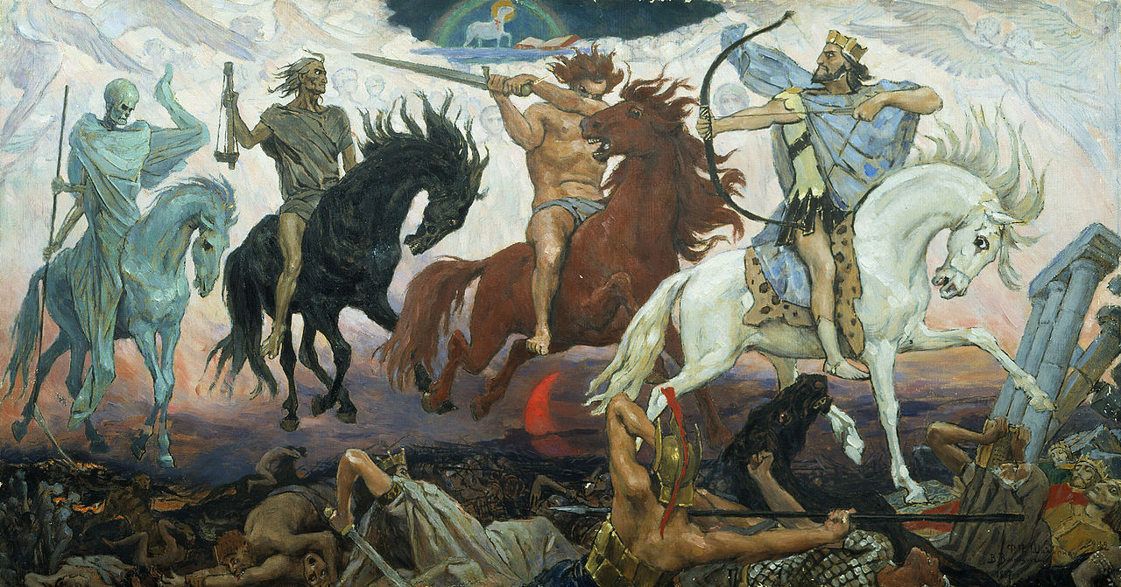
Four Horsemen of the Apocalypse, an 1887 painting by Victor Vasnetsov. The Lamb is visible at the top. Wikipedia.
https://en.wikipedia.org/wiki/Seven_seals#/media/File:Apocalypse_vasnetsov.jpg

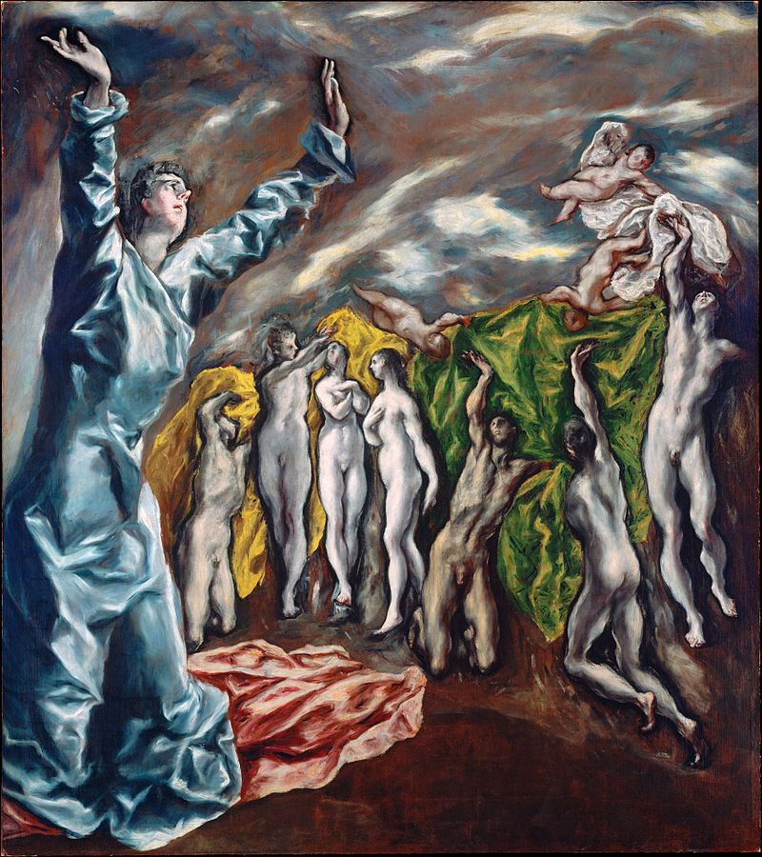

Opening of the Fifth Seal by El Greco. Wikipedia.
https://en.wikipedia.org/wiki/Seven_seals#/media/File:El_Greco,_The_Vision_of_Saint_John_(1608-1614).jpg

The First Four Seals (6:1-17)
- What can you understand from this chapter?
- Do you like horses? What type or what color? What does a white horse symbolize?
- Rev. 6:1–8:1 The vision of the Lamb receiving the scroll (4:1–5:14) introduces a series of seven visions as the scroll’s seals are broken. These visions show several ways in which the Lamb will bring his enemies to justice (seals 1–4). They also give the reason for his righteous wrath (seals 5 and 7) and describe the final judgment at history’s end (seal 6). ESV Study Bible.
  - What happens when the seventh seal is opened is described in Chapter 8.
- Rev. 6:1–8 As the Lamb opens each of the first four seals, one of the living creatures shouts, “Come!” Then a horse with its rider (or riders) responds. The horses’ colors are like those in Zech. 1:8–10; 6:1–8. They symbolize representatives sent by God to patrol the earth. Only by the Lamb’s permission can the horses and their riders inflict death. ESV Study Bible.
- The four horsemen represent conquest, war, famine, and death. These calamities characterize an indefinite period before the Second Coming (Mark 13:6-8). Such things occurred in the tumults of the Roman Empire, and may be expected to occur now and before the Second Coming. The imagery is capable of multiple applications throughout the history of the church. The seven churches were exhorted to put their confidence, not in the peace and prosperity supposedly achieved by Roman rule, but in God and His promises of a new world (2:17; 3:12; 21:4). When tumults occurred, they were assured that the Lamb was still in control. Such judgments represented the chastening hand of God on a rebellious world (9:20, 21). The saints would be cared for in the midst of such trials (ch. 7). They were sealed as a mark of ownership and protection (7:1-10; 9:4) and given perfect rest in the end (7:15-17). Such promises hold for saints throughout the church age, no less than for the seven churches. Reformation Study Bible.
- Rev. 6:1–2 the Lamb opened one of the seven seals. Some think this is the beginning of the great tribulation (see Matt. 24:21). This rider on a white horse probably symbolizes the desire of political and military leaders to make their kingdoms larger. This leads to war (red horse), famine (black horse), and epidemic disease (pale horse). ESV Study Bible.
- Rev. 6:3–4 The next horse is red, the color of blood. Its rider is given a great sword. This symbolizes permission to take peace from the earth. The result is that warring armies kill each other. ESV Study Bible.
- Rev. 6:5–6 The rider on the black horse carries scales for measuring grains and their prices. A voice reveals inflated grain prices (8 to 10 times normal). War and disruption of commercial routes will produce scarcity. This will drive prices up (see Deut. 28:49–57; 2 Kings 6:24–25; 7:1–2). The command not to harm the oil and wine may have a social significance, because the rich were the primary consumers of oil and wine. ESV Study Bible.
- Rev. 6:6 A quart of wheat. Famine will come, so severe that a laborer’s entire wages will go merely for food. Families will have to buy barley, a lower quality of grain. Oil and wine are spared, perhaps an indication that the rich will still be able to indulge themselves. Reformation Study Bible.
- Rev. 6:7–8 Death and Hades (the realm of the dead) ride the pale horse (the color of corpses). Their authority to kill is limited to a fourth of the earth. Sword, famine, and pestilence (here meaning epidemic disease, such as bubonic plague) sum up the disasters the red, black, and pale horses symbolize. They also echo covenant punishments given to Jerusalem in the exile (Ezek. 14:12–21). ESV Study Bible.
- Discussion
  - What does opening the scroll mean? To reveal God’s plan and to implement it.
  - When a seal was opened, certain plans were revealed.

The Fifth and Sixth Seals (6:9-17)
- Rev. 6:9–11 The fifth seal reveals the Lamb’s reason for devastating the earth. John sees the souls of believers slain for bearing witness about Jesus (compare 20:4). They are under the altar, like a sacrifice would be. Their lament, how long? Echoes the psalmists (Ps. 13:1; 89:46). White robe. A symbol of victory and purity (compare Rev. 3:4–5; 7:9, 14). ESV Study Bible.
- Rev. 6:12–17 The sixth seal previews the destruction of the first heaven and earth (20:11; 21:1). Earthquake. See Ex. 19:18; Ezek. 38:19–20; Hag. 2:6; Heb. 12:26–27. Rebellious humanity – from kings to everyone, slave and free – will seek protection from God and the Lamb (compare Isa. 2:20–21; Hos. 10:8). Their desperate question, “Who can stand?” (Nah. 1:5–6; Mal. 3:2), assumes none can. ESV Study Bible.
- Discussion
  - Do you believe that the world will end some day? If so, when will that happen and how would you describe that process? What do you think about the description in 6:12-17?
  - Are the punishments described above worthy of the offenses?
  - What shall we do now?

Wrapping up
- Hope that we can sense sins of human beings, the love of God, and thereby trusting Jesus.
- What are your favorite verses in this chapter?

Peter Luh, David Tai and Chunlong Liu, 1/10/2019
Peter Luh, Chunlong Liu, Koh Han Siew, Xiao Zhou, and Yu Ji, 5/8/2014
Copyright UCBSG, UConn Chinese Bible Study Group, 2014

