Revelation 4, 12/14/2018

Opening
- TIME 2018 Person of the Year: “The Guardians and the War on Truth.”
  - With a record number of reporters behind bars around the planet – the Committee to Protect Journalists documented 262 cases in 2017 – an avalanche of misinformation on social media and government officials from the United States to the Philippines dismissing critical, real reporting as “fake news,” Time is spotlighting a handful of journalists who have one thing in common: They were targeted for their work.
  - “Today, democracy around the world faces its biggest crisis in decades, its foundations undermined by invective from on high and toxins from below, by new technologies that power ancient impulses, by a poisonous cocktail of strongmen and weakening institutions,” TIME Editor-in-Chief Edward Felsenthal said in a statement after breaking the news Tuesday on NBC’s “Today” show.
  - https://www.nbcnews.com/news/us-news/time-s-2018-person-year-killed-imprisoned-journalists-n946311
https://www.google.com/search?q=time+2018+person+of+the+year&rlz=1C1CHBF_enUS760US760&source=lnms&tbm=isch&sa=X&ved=0ahUKEwjFrrmllZzfAhUJq4MKHfD0D88Q_AUIDygC&biw=1332&bih=878#imgrc=QhI67bxmftK7SM:
  - What is truth? What is fake news?
  - Does truth exist in today’s societies? Feel sad and angry?
  - What does the Bible say about such situations? About Christians in such situations? Will Revelation 2 and 3 tell us something?
- Have you been to the Forbidden City? What was your general impression?
  - What do you think about its layout and the place where the empire worked?
  - In those old days, could a civilian see the empire? If so, what was the process?
  - Have you visited the White House (and Capitol Hill)? What do you think about it?
  - Can you see the President, either in the States or in China? If so, what is the process?

- Have you heard about the tabernacle in the Old Testament? Can you describe it?
  - What did things inside the tabernacle represent? Replica of things in heaven.
  - The description of a tabernacle, located in Exodus chapters 25–27 and chapters 35–40, refers to an inner shrine (the most holy place) housing the ark and an outer chamber (holy place), with a lampstand, table for showbread, and altar of incense. An enclosure containing the sacrificial altar and bronze laver for the priests to wash surrounded these chambers. https://en.wikipedia.org/wiki/Tabernacle.
  - Who could go into the tabernacle? Under what conditions and in what process?
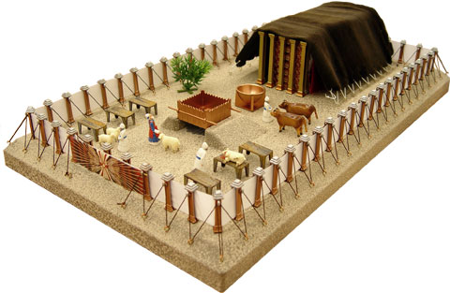
The tabernacle. http://av.goodseed.com/tabplace/images/tabernacle-painted.jpg
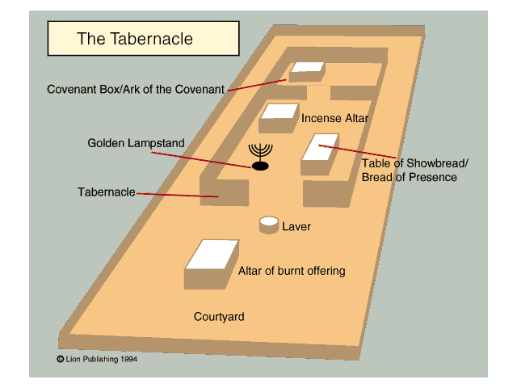
http://1.bp.blogspot.com/-7FeOUKXOr9U/TllLPfBhE0I/AAAAAAAAAIo/3lifWmtetT8/s640/tabdiagram.gif
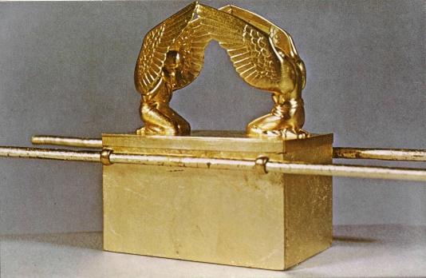
http://www.swedenborgstudy.com/books/G.deCharms_Tabernacle/images/Tabernacle-title-1.jpg

- Have you heard about the temple in the Old Testament? Can you describe it?
  - What did things inside the temple represent? Replica of things in heaven.
  - Essentially, Solomon's Temple was similar to the Tabernacle of the desert in its basic layout and design, only on a larger scale.
  - Who could go into the tabernacle? Under what conditions and in what process?

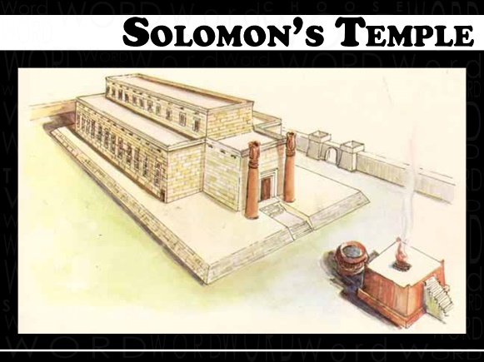
http://www.cfcmadison.org/wp-content/uploads/2012/01/1-Solomons-Temple.jpg
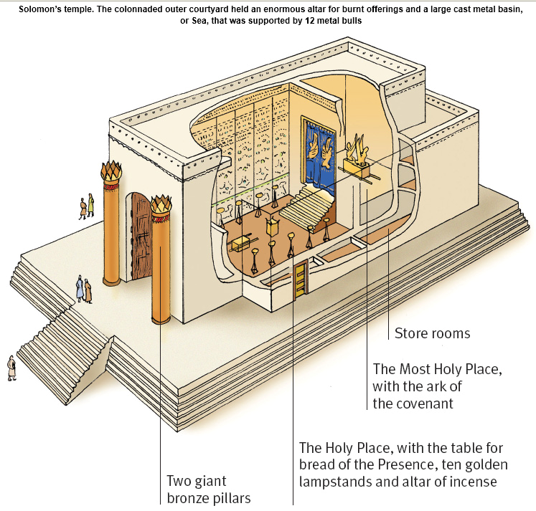
https://www.logos.com/media/blog/collins/collins2.png
- Will there be tabernacle or temple or their alike in heaven? What would they look like?
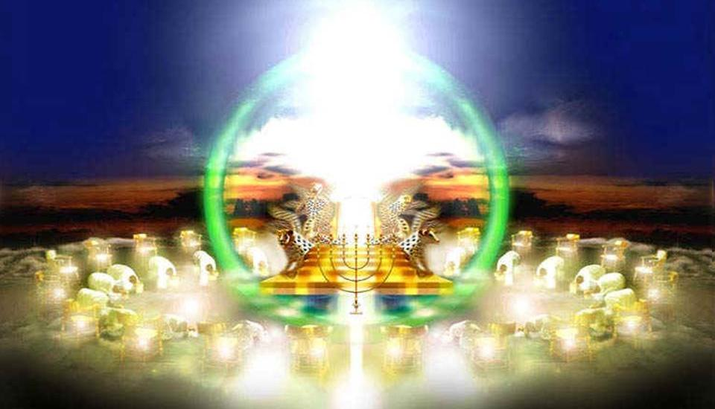
http://www.believetrust.com/bible/revelation-4-the-throne-in-heaven/
- What did we study last time? Revelation 3. To the Church in Sardis. To the Church in Philadelphia. To the Church in Laodicea. These were precious letters to churches at that time. What must take place afterward? Read Revelation 4.

The Throne in Heaven (4:1-11)
- Rev. 4:1–5:14 These visions begin with a door standing open in heaven, leading to a vision of God on his throne receiving ceaseless worship, and of the Lamb, who receives from him a mysterious sealed scroll. ESV Study Bible.
- Rev. 4:1–2 the first voice . . . like a trumpet. Compare 1:10. In heaven, John sees a throne, with one seated on it, adored by his heavenly attendants as “our Lord and God” (4:11; compare Isa. 6:1–5; Ezek. 1:26–28). ESV Study Bible.
  - Isa. 6:1–6 In the year that King Uzziah died I saw the Lord sitting upon a throne, high and lifted up; and the train of his robe filled the temple. Above him stood the seraphim. Each had six wings: with two he covered his face, and with two he covered his feet, and with two he flew. And one called to another and said: “Holy, holy, holy is the Lord of hosts; the whole earth is full of his glory!” And the foundations of the thresholds shook at the voice of him who called, and the house was filled with smoke. And I said: “Woe is me! For I am lost; for I am a man of unclean lips, and I dwell in the midst of a people of unclean lips; for my eyes have seen the King, the Lord of hosts!” Then one of the seraphim flew to me, having in his hand a burning coal that he had taken with tongs from the altar.
  - Ezek. 1:26–28 And above the expanse over their heads there was the likeness of a throne, in appearance like sapphire; and seated above the likeness of a throne was a likeness with a human appearance. And upward from what had the appearance of his waist I saw as it were gleaming metal, like the appearance of fire enclosed all around. And downward from what had the appearance of his waist I saw as it were the appearance of fire, and there was brightness around him. Like the appearance of the bow that is in the cloud on the day of rain, so was the appearance of the brightness all around.
- Rev. 4:3 John describes God’s glory in bright colors – jasper, carnelian, rainbow, emerald. The jewels mentioned in Revelation (compare 21:19–20) are not meant to be interpreted individually but together represent God’s splendor and majesty. John does not precisely describe the Almighty’s visible features (compare Isa. 6:1–6; Ezek. 1:26–28). Perhaps he had no words to describe what he saw. ESV Study Bible.

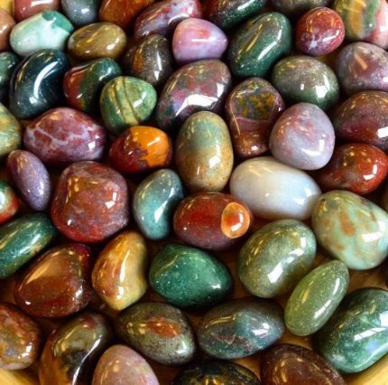
Jasper. https://www.google.com/search?rlz=1C1CHBF_enUS760US760&biw=1440&bih=881&tbm=isch&sa=1&ei=yQYSXOuBDIjSjwSCkqqABA&q=jasper&oq=jasper&gs_l=img.1.0.35i39j0i67j0j0i67j0l2j0i67l3j0.2434600.2435796..2438328...0.0..0.234.1394.2-6......1....1..gws-wiz-img.C6a0cofISZo#imgrc=aC0piZJYH9zNIM:

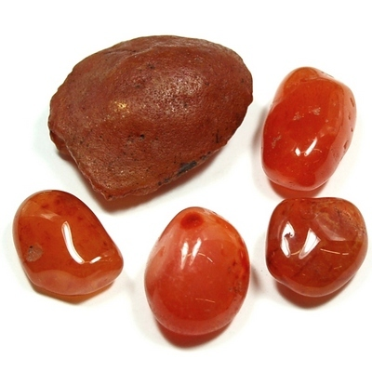
Carnelian. https://www.google.com/search?rlz=1C1CHBF_enUS760US760&biw=1440&bih=881&tbm=isch&sa=1&ei=UBASXLatFZKwwgT1qK3YCA&q=carnelian&oq=carnelian&gs_l=img.1.0.0i67j0l8j0i67.176447.176447..178068...0.0..0.73.73.1......1....1j2..gws-wiz-img.oUXkonkGW2U#imgdii=IbSLqMFlWZ8z5M:&imgrc=omoC9d3VJjlacM:
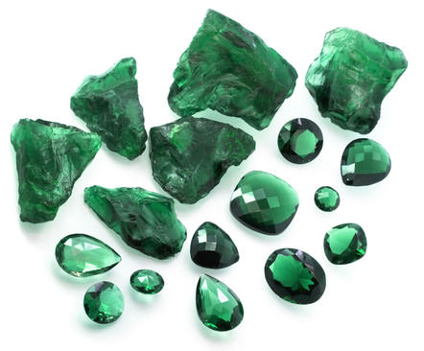
Emerald. https://www.google.com/search?rlz=1C1CHBF_enUS760US760&biw=1440&bih=881&tbm=isch&sa=1&ei=AxESXMTzMIifjgTM8ZCYDw&q=emerald&oq=emerald&gs_l=img.1.0.35i39j0i67j0j0i67j0l6.151148.151148..152342...0.0..0.71.71.1......1....1j2..gws-wiz-img.jElcRcQvSNg#imgrc=kY2QQC7IN9MZ1M:
- Rev. 4:4 On twenty-four thrones sat twenty-four elders. Their number may reflect the orders of priests serving in the OT temple (see 1 Chron. 24:7–19). More likely they symbolize the unity of God’s people. This includes OT Israel (led by the heads of the 12 tribes) and the NT church (led by the 12 apostles). Their thrones look like the ones in God’s heavenly court in Dan. 7:9–10 (compare Rev. 20:4). ESV Study Bible.
  - Dan. 7:9–10 “As I looked, thrones were placed, and the Ancient of Days took his seat; his clothing was white as snow, and the hair of his head like pure wool; his throne was fiery flames; its wheels were burning fire. A stream of fire issued and came out from before him; a thousand thousands served him, and ten thousand times ten thousand stood before him; the court sat in judgment, and the books were opened.
  - Rev. 20:4 Then I saw thrones, and seated on them were those to whom the authority to judge was committed. Also I saw the souls of those who had been beheaded for the testimony of Jesus and for the word of God, and those who had not worshiped the beast or its image and had not received its mark on their foreheads or their hands. They came to life and reigned with Christ for a thousand years.
- Rev. 4:5 Lightning, rumblings, and thunder display the terrifying splendor of God’s glory, as at Mount Sinai (Ex. 19:16). ESV Study Bible.
  - Ex. 19:16 On the morning of the third day there were thunders and lightnings and a thick cloud on the mountain and a very loud trumpet blast, so that all the people in the camp trembled.
- Rev. 4:6-8 The sea of glass (4:6) is the transparent pavement surrounding God’s throne. Separating heaven above from the earth below, its transparent tranquility shows heaven’s peace in contrast to earthly turmoil. Four living creatures have the features of cherubim (full of eyes; lion; ox; man; eagle) and seraphim (six wings; “Holy, holy, holy”). Previous prophets also saw these creatures (Isa. 6:2–3; Ezek. 1:10, 18). ESV Study Bible.
  - Ezek. 1:10 As for the likeness of their faces, each had a human face. The four had the face of a lion on the right side, the four had the face of an ox on the left side, and the four had the face of an eagle.
  - Ezek. 1:18 And their rims were tall and awesome, and the rims of all four were full of eyes all around.
- Rev. 4:9–11 God’s receiving of power does not suggest that an omnipotent being can become stronger. Rather, the strength of his creatures is used to honor him. ESV Study Bible.
- Discussion
  - What do you think about God’s throne in haven? How does it compare with the Forbidden City, the White House, or the Kremlin?
  - How do you compare the description here with those of the tabernacle and the temple? Why?
  - What are the 24 elders doing? Are they joyous there?

Wrapping up
- Do you see the linkage between the Old Testament and the New Testament from this Chapter?
- What is the most surprising thing you learned from this Chapter? How would that affect your life from now on?

Peter Luh and Chunlong Liu, 12/12/2018
Peter Luh, Chunlong Liu, Shiqi Yin, Xiao Zhou, 5/1/2014
Copyright UCBSG, UConn Chinese Bible Study Group, 2014, 2018

