Revelation 3, 12/7/2018

Opening
- Have you ever felt lonely in a bustling city or in a crowded and noisy party? Why?
- Do you like to drink coke cold or hot or room temperature? How about beer? Coffee? Tea? Why?
  - As a person, what does it mean by cold or hot, or lukewarm? Shall we be cold or hot, or lukewarm? Why?
  - As a church or a Bible study group, what does it mean by cold or hot, or lukewarm? Shall we be cold or hot, or lukewarm? Why?
- Have you ever visited big churches in Europe? How do they look like? What conditions are most of them in?
  - How about many US churches?
  - How about SCCC and UCBSG? Do we understand our strengths and weaknesses? What should be improve and how?
  - How will God treat His faithful churches and individuals?
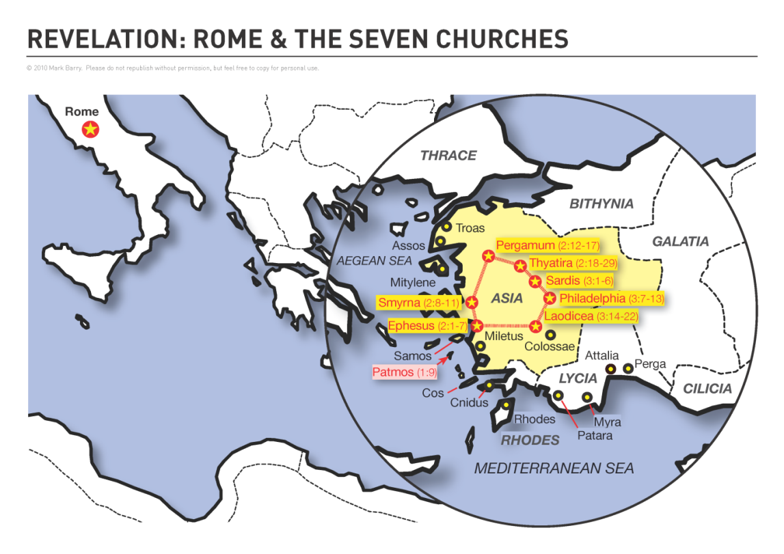
http://visualunit.files.wordpress.com/2013/10/rev_map.png

To the Church in Sardis (3:1-6)
- Rev. 3:2–3 The church in Sardis is near death, but not beyond Christ’s ability to wake them up. Twice in its history Sardis had been conquered when its watchmen failed to see the enemy climbing its cliffs and walls, so the people knew the importance of alertness. ESV Study Bible.
  - Examples of such churches having a good reputation but are dead?
- Rev. 3:4–5 There is hope for a few names, alert and faithful believers. Christ promises them the conqueror’s reward. They will have communion with him (walk with me) and the white clothing of victory. Their name is secure in his book of life (20:15). ESV Study Bible.
  - What does “walk in white” mean? See v. 18.
- Discussion
  - Have you visited churches in Europe? Churches in the States? What do you think about them?
  - Have you “waken” someone up – physiologically and spiritually? Which one is easier? Why?
  - “He who has an ear, let him hear what the spirit says to the churches.” Is it easy for someone to listen to what the spirit says to him or her? How about for us to hear? How can we hear? Wake up spiritually.

To the Church in Philadelphia (3:7-13)
- What does the word “philadelphia” mean? Love of brothers or sisters, brotherly love. In the NT the love which Christians cherish for each other as brethren. http://www.biblestudytools.com/lexicons/greek/nas/philadelphia.html.
- Rev. 3:7 Jesus holds the key of David. He has absolute authority to admit to or exclude from God’s kingdom (see Isaiah 22:22, Matthew 16:19). NIV Study Bible.
  - Isaiah 22:22. And I will place don his shoulder the key of the house of David. He shall open, and none shall shut; and he shall shut, and none shall open.
  - Matthew 16:19. I will give you the keys of the kingdom of heaven, and whatever you bind on earth shall be bound in heaven, and whatever you loose on earth shall be loosed in heaven.
- Rev. 3:10 hour of trial. This trial is coming on the whole world. It will happen before the day of judgment. Revelation envisions a brief future period of intense persecution for the church (see 19:19; 20:7–9). This time will include ever more intense manifestations of God’s wrath against rebellious humanity (6:10; 8:13; 11:10; 13:8, 12, 14; 17:2, 8). Some believe this verse means Christ will take believers out of the world before a literal “great tribulation” period begins (the “pretribulation rapture” view). Other interpreters, however, see this as God’s promise to protect and remain faithful to believers who endure patiently during this difficult time. ESV Study Bible.
- Rev. 3:12 As a pillar in God’s temple, inscribed with the name of God. The one who conquers can never be excluded from God’s presence, for he will dwell in God’s new Jerusalem (21:2) as David’s royal heir (3:7). ESV Study Bible.
  - Names revealed character. Christ’s new name symbolizes all that he is by virtue of his redemptive work for humankind. This awaits the Second Advent. NIV Study Bible.
- Discussion
  - The church in Philadelphia is the second church among the seven without rebuke after the church in Smyrna. How could it do that? Wealth? Knowledge? Endure patiently?
  - How much strength do we have? How can we keep God’s word and do not deny Jesus’ name? (V. 8)

To the Church in Laodicea (3:14-22)
- Rev. 3:14–22 Laodicea is criticized for its spiritual immaturity. The city was a commercial center. It had thriving medical and textile industries. It was so wealthy that it declined imperial disaster relief after an earthquake in A.D. 60. The city did not see itself as “poor, blind, and naked” (v. 17), but Jesus does not find anything in its church to praise. Laodicea was famous for its worship of Zeus. ESV Study Bible.
- Rev. 3:14 Jesus contradicts the church’s boast, “I am rich, I have prospered, and I need nothing” (v. 17). The beginning of God’s creation. This does not mean that Jesus is God’s first creation. It means that he is the one who began God’s creation. This phrase signifies Christ’s sovereign rule over the created order (see Rev. 21:6; 22:13). ESV Study Bible.
- Rev. 3:15–16 The church’s lukewarm indifference was disgusting to Jesus. Cold and hot water both represent something positive, for cold water refreshes in the heat and hot water gives warmth in the cold. ESV Study Bible.
- Rev. 3:17–18 The Laodiceans were spiritually blind, bankrupt, and naked. They had no resources to buy from Jesus gold or garments or salve for their eyes. They could “purchase” these necessities only by his grace (see Isa. 55:1–4). ESV Study Bible.
- Rev. 3:19–20 Like a loving father, Christ will reprove those whom he loves (compare Prov. 3:12). I stand at the door and knock. Jesus is the master of the house. He expects alert servants to respond immediately to his signal and welcome his entrance (Luke 12:35–36). Eat with him. A picture of close personal fellowship. ESV Study Bible.
- Discussion
  - Jesus is not saying that He wishes they were either spiritually hot or spiritually cold rather than being spiritually lukewarm. Nowhere does God desire for His people to have cold hearts. Rather, Jesus explains what He means by being lukewarm in the next verse. “For you say, I am rich, I have prospered, and I need nothing, not realizing that you are wretched, pitiable, poor, blind, and naked” (v. 17). The lukewarm person is not one who is mildly passionate about God. Rather, the lukewarm person is one who has lost his dependence on God. In his arrogance, he believes he has no need of Christ’s righteousness because he has enough of his own. https://www.ligonier.org/learn/articles/letter-church-laodicea/
  - What do you think about lukewarm? What situation are we in now?
  - Jesus knock at the door. Will you open?

Wrapping up
- He who has an ear, let him hear what the Spirit says to the churches. Are we listening?
- What do we need to improve the most, as a person and as a church?
- What are your favorite verses in this chapter?

Peter Luh and Chunlong Liu, 12/6/2018
Peter Luh and Koh Han Seow, 4/10/2014
Copyright USBSG, UConn Chinese Bible Study Group, 2014, 2018

