Revelation 2, 11/29/2018

Opening
- Have you lost something important recently? Have you found it? Where and how?
  - If your love to your spouse has been significantly dropped, how can you rekindle it?
- As a student, employee, or a family member, have you been awarded because of your work? Why and how?
  - Why will a Christian be awarded by God? Because, e.g., he/she has knowledge of Him and is willing to serve Him?
  - How will a Christian be awarded by God?
- There are certain words that have to be used with care. “He is good, but …” What does the sentence mean? “She is beautiful, however, …” “But,” “however,” “yet,” .. are “eraser words” that erase whatever you say earlier. The focus is on the statement afterwards.
  - Use these words with care. If not, you might offend many without realizing that.
  - Try to find such words in Revelation 2 and 3.
- What is a good church? A bad church? A good Christian? A bad Christian?
  - Revelation Chapters 2 and 3 are on seven churches. Which churches? What were their major strengths and weaknesses? How did Jesus warn or encourage them?
  - What would be the punishments or rewards?
  - What are the strengths and weaknesses of today’s churches? SCCC and UCBSG? Christians? Non-Christians?
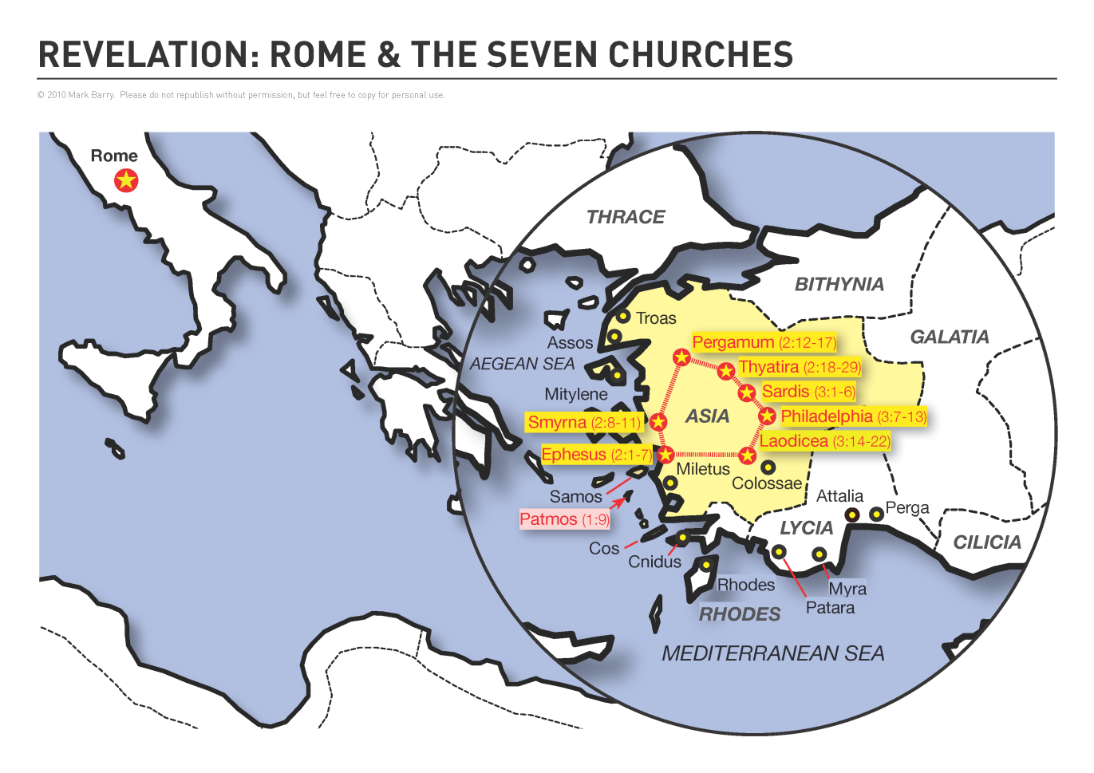
http://visualunit.files.wordpress.com/2013/10/rev_map.png

To the Church in Ephesus (2:1-6)
- There is a structure across the seven letters. The receiving church, description of Christ, praising, warning, encouragement and promising.
- Rev. 2:1–7 To Ephesus. The church in Ephesus was commended for doctrinal vigilance and endurance but was rebuked for its loss of love. Ephesus was a port city on the west coast of Asia. The city’s landmark was the temple of Artemis, and one of its symbols was the date palm tree (contrast “tree of life,” v. 7). ESV Study Bible.
- Rev. 2:1 Angels may refer to human messengers or to angels. The prominence of angels in Revelation would support the latter meaning here. Reformation Study Bible.
- Rev. 2:4–5 the love you had at first. One interpretation is that Ephesus had lost its early love for Christ. Another interpretation is that Ephesian believers had lost love for one another and needed to revive the compassionate works you did at first. Many interpreters think both are in view, since love for Christ and love for one another are related. Remove your lampstand means that both in the near future and when Christ returns, they would lose their status as a church and Christ would treat them like apostate Israel. ESV Study Bible.
- Rev. 2:6 Nicolaitans. An otherwise unknown heretical group. They seduced God’s people to participate in idolatry and sexual immorality (vv. 14–15). They may have presented immorality as freedom in Christ (compare 1 Cor. 6:12–20; 8:1–11:1). ESV Study Bible.
- Rev. 2:7 Tree of life. Access to this tree in Eden, and the eternal life it promised to the pure, was banned after humanity’s fall (Gen. 3:22–24). It reappears in the New Jerusalem, its roots watered by living water from God’s throne, its fruit a constant source of nourishment, and its leaves bringing healing to the city’s inhabitants, whose names appear in the Lamb’s book of life (Rev. 22:1–2). ESV Study Bible.
- Discussion
  - What are the statuses of big churches in Europe? Mostly are tourist attractions.
  - What is the “eraser word” in this letter?
  - What are the implications of this letter on us today?

To the Church in Smyrna (2:7-11)
- Rev. 2:8–11 To Smyrna. Churches in Smyrna and Philadelphia (3:7–13) receive no rebuke from King Jesus, who encourages them as they endure persecution. Roman Smyrna (modern Izmir) was a harbor city renowned for its temple to the Mother Goddess and for its provincial imperial cult temples to Tiberius (1st century a.d.) and Hadrian (2nd century). Strabo in his Geography (14.1.37) reported early-first-century Smyrna to be a beautiful city possessing paved streets, a library, a gymnasium, and a shrine to Homer (荷马, 850 B.C.), who may have been born there. ESV Study Bible.
- Rev. 2:10–11 ten days … unto death. The tribulation for Smyrnan Christians will be brief (cf. Dan. 1:12–16), yet it may end not in discharge from prison but in martyrdom, an even better release (Rev. 7:14–17). ESV Study Bible.
- Discussion
  - How was Jesus described in this letter? Why? Implications? – Trinity!
  - Are you poor or rich?
  - How can one face martyrdom with faith and in peace

To the Church in Pergamum (2:12-17)
- Rev. 2:12–17 To Pergamum. The church at Ephesus resisted false teaching, and Smyrna endured persecution. Believers at Pergamum faced both assaults, withstanding persecution well but wrongly condoning dangerous deception. Pergamum was built on terraces leading up the only accessible slope of its acropolis. ESV Study Bible.
- Rev. 2:14–16 As the Israelites migrated through the wilderness, the prophet Balaam, prevented from cursing them, advised Moab’s king to seduce them into both sexual and spiritual adultery (Num. 25:1–2; 31:16). ESV Study Bible.
- Rev. 2:17 Hidden manna. Perhaps an allusion to the manna preserved in the Most Holy Place of the tabernacle (Ex. 16:33-35; Heb. 9:4). Christ promises to nourish the faithful with an unfailing supply of heavenly, spiritual food. Reformation Study Bible.
- Rev. 2:17 Historically, a white stone was given to victors at games for entrance to banquets (cf. the messianic banquet); such a stone was also used by jurors at trials to vote for acquittal. The new name, given to the one who holds fast to Jesus’ name (2:13), may refer to the Holy Spirit’s work of conforming believers to the holiness of Christ (Rom. 8:29). The manna and the white stone suggest differing types of eternal blessings and rewards, as appropriate in each situation. ESV Study Bible.
- Discussion
  - Have you seen modern Balaam? Have we been Balaam before?
  - Do you want to have the hidden manna?

To the Church in Thyatira (2:18-29)
- Rev. 2:18–29 To Thyatira. Thyatira was a politically and culturally marginalized city, finding its identity economically, with guilds dealing in metals and fabric (Acts 16:14). Guilds celebrated their patron deities in periodic festivities, so Christians may have been tempted toward the message of a “prophetess” who advocated participation in illicit sex and food sacrificed to idols, both staples of the social scene. ESV Study Bible.
- Rev. 2:19–20 Thyatira’s strengths and weaknesses are the inverse of those at Ephesus. This church is strong in love evidenced in works; but it lacks discernment and tolerates heresy. The self-proclaimed prophetess who endorses idolatry and immorality resembles Jezebel of Tyre, who married Israel’s King Ahab and violently imposed Baal-worship on the northern kingdom (1 Kings 16:30–33; 19:1–2; 21:25-26). Many scholars think “Jezebel” represented an actual woman “prophetess” who was leading people astray in the church of Thyatira. In any case, she symbolizes the prostitute Babylon, who seduces through pleasure and luxury as well as ruthless violence (Revelation 17). ESV Study Bible.
- Rev. 2:21–23 The Lord has given the “prophetess” (v. 20) time to repent, or the church time to bring her to discipline. Neither has occurred, and she proliferates lovers and children – spiritual offspring who exhibit her influence and will share in her great tribulation, unless they repent. ESV Study Bible.
- Rev. 2:26–28 The morning star is Christ himself (cf. Rev. 22:16), Israel’s ruler and rescuer. ESV Study Bible.
- Discussion
  - Compare how Jesus was described in the four letters. What can you say?
  - Compare how Christians were awarded. What can you say?

Wrapping up
- What are the messages to today’s churches? What are the messages to UCBSG and SCCC? To every one of us as a Christian or a seeker?
- What are your favorite verses in this chapter?

Peter Luh and David Tai, 11/28/2018
Peter Luh, 4/3/2014
Copyright USBSG, UConn Chinese Bible Study Group, 2014

