Revelation 1, 11/16//2018

Opening
- People often seek fortunetelling. Why?
  - What are differences between fortunetelling vs. what the book Revelation tells us?
  - What does the Bible say about fortunetelling? The Bible forbids that. Why?
- Knowing the future, how would that impact the current?
  - Examples?
  - In optimization, the only general way to solve dynamic optimization problems in uncertain environments is “Dynamic Programming” – working backwards in time, from the last stage and back. Knowing the future will therefore significantly help the present.
  - Without fortunetelling, how can we know the future?
- On a grander scale, human beings have always been intrigued by several key questions, e.g., origin of the universe, life beyond the earth, end of the world, and meaning of life.
  - Do you have answers to some of the questions?
  - How to find answers to these questions?
  - What are the impacts on the current?
  - What are the roles or churches in all these, especially to the end time?
- What can we say about the future based on several key events that have captured people’s attention? Which are what?
  - Midterm election in the States.
  - California wildfire.
  - The death of Saudi journalist Jamal Khashoggi in Turkey.
  - The crash of Lion Air’s new Boeing 737 in Indonesia killing all 189 on board.
  - The spiritual war among various forces.
- What do you want to learn from the study of the book Revelation? What is the purpose for us to study it?
  - To learn what God wants us to know about the end of the world, the meaning of life, and beyond.
  - To examine us as a body of Christ.

Introduction to Revelation
- Author and Title: The divine author identified in the opening verse, Jesus the Messiah, has authority from God to describe coming events to his servant John (see also 1:4, 9; 22:8) for communication to the church. Without denying his own role in the composition of the book, John presents himself more as a recipient and recorder of visions than as the author of Revelation’s message. ESV Study Bible.
- Date: Most scholars date Revelation in the mid-90s.
- Themes: Revelation unveils the unseen spiritual war in which the church is engaged: the cosmic conflict between God and his Christ on the one hand, and Satan and his evil allies (both demonic and human) on the other. In this conflict, Jesus the Lamb has already won the decisive victory through his sacrificial death, but his church continues to be assaulted by the dragon, in its death-throes, through false teaching (such as that of the Nicolaitans, 2:6, 15), persecution (2:10, 13), compromise with surrounding paganism through idolatry and immorality (2:14, 20–21), and spiritual complacency (3:1–3, 15–17). By revealing the spiritual realities lying behind the church’s trials and temptations during the time between Christ’s first and second comings, and by dramatically affirming the certainty of Christ’s triumph in the new heaven and earth, the visions granted to John both warn the church and fortify it to endure suffering and to stay pure from the defiling enticements of the present world order. ESV Study Bible.
- Structure: Revelation is composed of a prologue (1:1–8), a body (1:9–22:5), and an epilogue (22:6–21). The prologue and epilogue are linked by repeated themes: an angel sent to show God’s servants what must soon take place (1:1; 22:6, 16), blessings on those who keep the prophecy (1:3; 22:7, 9), John’s self-identification (1:1, 4; 22:8), and the designation of God as Alpha and Omega (1:8; 22:13). ESV Study Bible.
- The body is divided into four unequal parts by the expression “in the Spirit,” which signifies the beginning of an ecstatic vision. Pastor Yoakum.
  - The vision of the Son of Man and the seven letters to the churches, 1:9-3:22. “On the Lord’s Day, I was in the spirit,” 1: 10.
  - The major apocalyptic vision, 4:1-16:21. “At once, I was in the Spirit,” 4:2. This part includes Seven Seals on a scroll (4:1–8:1, preparation for the judgments), Seven Trumpets (8:2–11:19, delivery of the judgments), and Seven Bowls of wrath (chs. 15–16, pouring out of God’s wrath).
  - The vision of judgment of the great harlot, 17:1-21:8. “Then the angel carried me away in the Spirit into a desert,” 17:3.
  - The vision of the New Jerusalem, 21:9-22:5. “And he carried me away in the Spirit to a mountain great and high,” 21: 10.
- The general movement of the book is from “the things that are” – the first-century churches’ situation (chs. 2–3) – to “the things that are to take place after this,” climaxing with the destruction of the enemies of God and the presentation of the church as the Lamb’s bride in a new heaven and earth.
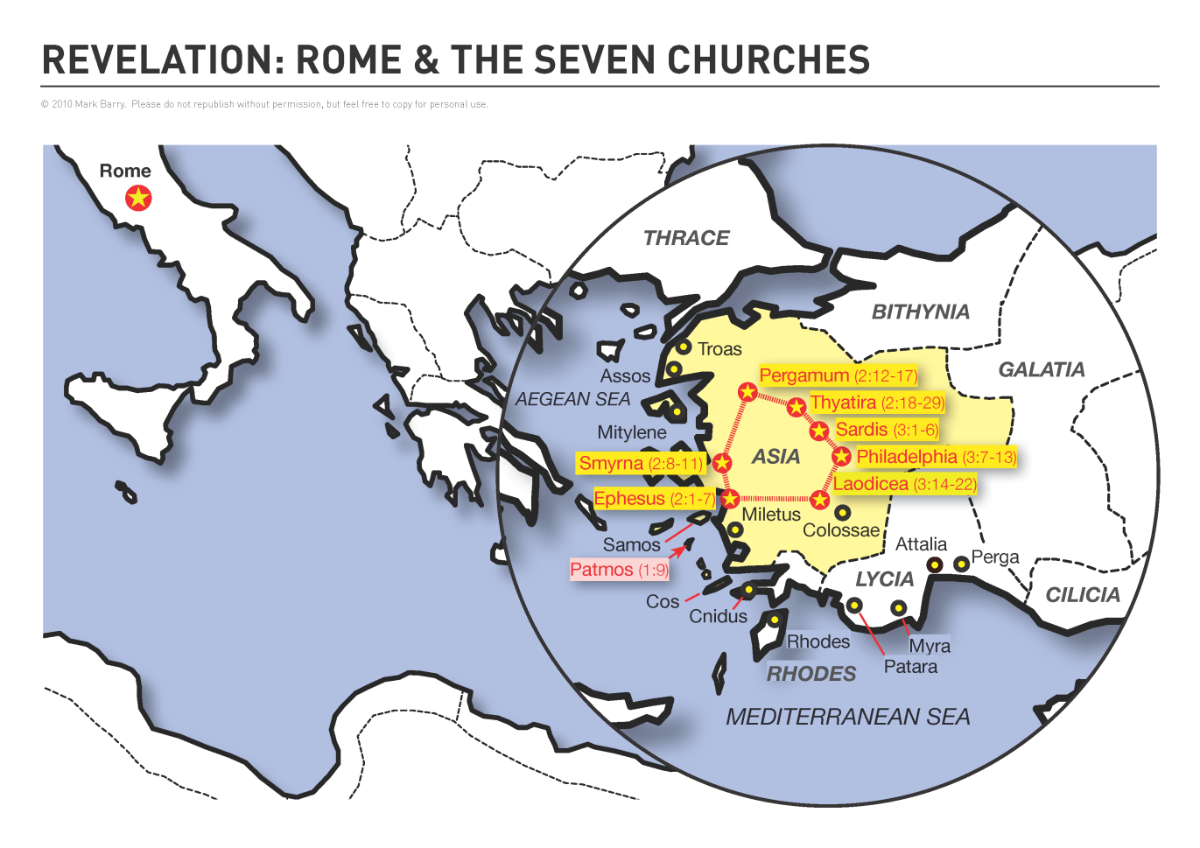
http://visualunit.files.wordpress.com/2013/10/rev_map.png

Prologue (1:1-3)
- Rev. 1:1–3 Title, Transmission, Promise of Blessing. The opening paragraph identifies this book’s genre (“revelation” or apocalypse, a disclosure of unseen realities), its divine author (“Jesus Christ”), and the process by which he is conveying it through the human author (“his servant John”) to believers (“his servants”). It then pronounces the first of seven benedictions on those who rightly receive the book’s message. ESV Study Bible.
- Rev. 1:3 Blessed. The first of seven blessings is given to those who hear and keep God’s Word. Later blessings (14:13; 16:15; 19:9; 20:6; 22:7, 14) commend purity and perseverance, even to the death. ESV Study Bible.
- Discussion
  - What does “soon” mean to boyfriend or girlfriend? To spouses? In the Bible?
  - Who are blessed and why?
  - Do you want to be blessed? Then how?

Greetings and Doxology (1:4-8)
- Rev. 1:4–6 Epistolary Opening. This greeting identifies author and recipients, then pronounces blessing upon the recipients. ESV Study Bible.
  - The seven churches that are in Asia. Since churches existed in other cities of Roman Asia (e.g., Colossae, Troas), Christ’s selection of “seven,” symbolizing completeness, implies that he addresses the whole church through them.
  - The seven spirits. Revelation presents the Holy Spirit as one person (3:6, 13; cf. Eph. 4:4), but he also appears as “seven spirits” (cf. Rev. 3:1; 4:5; etc.), representing perfection, and as “seven torches of fire” (4:5) and “seven eyes” (5:6) to express his omnipresence and omniscience.
- Rev. 1:7–8 Coming with the clouds. Jesus is the Son of Man. He will have a universal kingdom (see Dan. 7:13–14). ESV Study Bible.
  - His subjects pierced him (Zech. 12:10).
  - Wail. A reaction to judgment.
- Discussion
  - Can you see trinity in these verses? Where?
  - How was God described? Can you find a similar description in Exodus?
    - Exodus 3:14. God said to Moses, “I AM WHO I AM.”
  - Why will all the peoples of the earth mourn because of the coming of Christ? Is this in sharp contrast with those who will be blessed?

John’s Vision of Christ (1:9-20)
- Rev. 1:9–20 The Son of Man among His Churches. Jesus Christ appears in resplendent and overpowering glory to reassure his churches that by his death and resurrection he has control of the danger and death that threaten them. Although he is exalted in heaven, he is also present with his churches on earth and knows their needs better than they themselves do. ESV Study Bible.
- Rev. 1:9 John’s confinement on Patmos, an Aegean island to which Rome exiled political criminals, shows that he is a partner with the churches’ tribulation and patient endurance. ESV Study Bible.
  - Patmos is an arid island approximately 24 square miles (62 sq. km) in area and roughly 40 miles (64 km) from the mainland of Asia Minor.
- Rev. 1:10 in the Spirit. John was conscious of being surrounded by the manifest presence of the Holy Spirit. Such strong influence of the Holy Spirit leads to prophetic visions (4:2; 17:3; 21:10; cf. Ezek. 3:12). ESV Study Bible.
- Rev. 1:11 The order in which the churches are listed traces the route along which a courier from Patmos would have carried the scroll. ESV Study Bible.
- Rev. 1:15-16. Christ’s feet, like burnished bronze, will crush any opponents. God’s Word, which like a two-edged sword, searches hearts and judges rebels. ESV Study Bible.
- Rev. 1:18 I died … I am alive forevermore. Paradoxically, this ever-living One died to redeem believers and now lives forever as “the firstborn of the dead.” Because Jesus died and rose again, John must “fear not,” and the churches should not fear death, because Jesus has conquered it forever. ESV Study Bible.
- Discussion
  - What do you think about v. 17 Then he placed his right hand on me and said: “Do not be afraid. I am the First and the Last”? Is that wonderful?

Wrapping up
- Genesis 2:9. “Tree of the knowledge of good and evil” and “Tree of life.” What happened to the “Tree of life”? Will we miss it forever?
- Looking back at v. 1:3. Do you believe it? What are the implications? Tree of life!
- What are your favorite verses in this chapter?

Peter Luh, David Tai and Chunlong Liu, 11/15/2018
Peter Luh, Koh Han Seow, Chunlong Liu and Xiao Zhou, 3/28/2014
Copyright UCBSG, UConn Chinese Bible Study Group, 2013, 2018

