2 Samuel 8-9. Establishment of David’s ruling & David’s kindness to Mephibosheth
6/1/2018

Opening
- What are the neighboring countries of the States? What are the relationships between the States and them? Why? How about China? Historically? Why? How about Israel now? How about Israel at King David’s time? Why?
  - Deut. 9:4, 5. Do not say in your heart, after the Lord your God has thrust them out before you, ‘It is because of my righteousness that the Lord has brought me in to possess this land,’ whereas it is because of the wickedness of these nations that the Lord is driving them out before you. Not because of your righteousness or the uprightness of your heart are you going in to possess their land, but because of the wickedness of these nations the Lord your God is driving them out from before you, and that he may confirm the word that the Lord swore to your fathers, to Abraham, to Isaac, and to Jacob.
  - Joshua 6:17. On the seventh day they rose early, at the dawn of day, and marched around the city in the same manner seven times. It was only on that day that they marched around the city seven times. And at the seventh time, when the priests had blown the trumpets, Joshua said to the people, “Shout, for the Lord has given you the city. And the city and all that is within it shall be devoted to the Lord for destruction. Only Rahab the prostitute and all who are with her in her house shall live, because she hid the messengers whom we sent.
- What are the forms of government now? Historically speaking, in China, in Israel, and at David’s time? In the future?
- What are critical resources? Gold, silver and bronze? Horses? Oil? Data and intelligence? In the future?
- In South Korea, many past presidents went to jail after stepping down. Historically, when a new regime came into power, what happened to the old leaders who were defeated? What happened to Saul’s descendants after he was killed and his kingdom destroyed? Why?
- Do you remember what we discussed last Friday? The Lord's Covenant with David. David's Prayer of Gratitude. What is the significance of the Lord’s covenant with David?

Outline (ESV Study Bible)
- Story of King David (1:1–20:26)
  - David and the death of Saul (1:1–27)
  - David becomes king (2:1–5:5)
  - Jerusalem, the city of David (5:6–25)
  - Zion, the place of worship (6:1–23)
  - Davidic covenant: eternal throne (7:1–29)
  - Catalog of David’s military activities (8:1–18)
  - Mephibosheth (9:1–13)
  - Israel-Ammon war (10:1–12:31)
    - Beginning of Israel-Ammon war (10:1–19)
    - David and Bathsheba (11:1–12:25)
    - End of Israel-Ammon war (12:26–31)
  - Absalom’s banishment and reinstatement (13:1–14:33)
  - Absalom’s rebellion (15:1–19:43)
    - Absalom’s conspiracy (15:1–12)
    - David’s escape from Absalom (15:13–16:14)
    - Ahithophel and Hushai (16:15–17:23)
    - David arrives at Mahanaim (17:24–29)
    - Death of Absalom (18:1–19:8a)
    - David’s return to Jerusalem (19:8b–43)
  - Sheba’s rebellion (20:1–26)
- Epilogue (21:1–24:25)
  - Famine and the death of Saul’s sons (21:1–14)
  - Philistine wars (21:15–22)
  - Song of David (22:1–51)
  - Last words of David (23:1–7)
  - David’s heroes (23:8–39)
  - The census and the threshing floor (24:1–25)

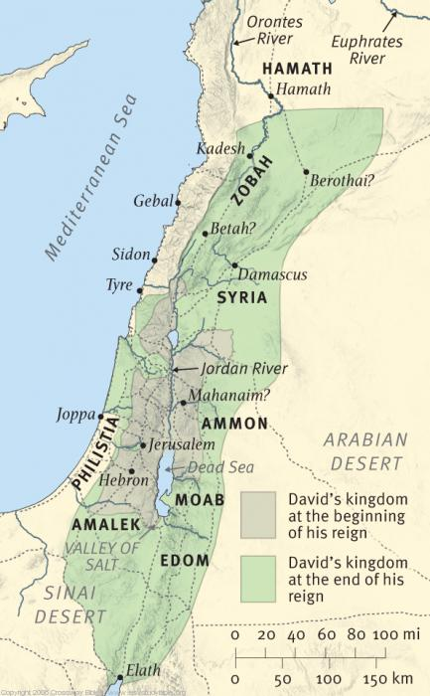
Geographical setting of 2 Samuel

David's Victories (8:1-14)
- 2 Sam. 8:1–18 Catalog of David’s Military Activities. Chapter 8 is a catalog of David’s military victories, from the old enemies, the Philistines, to the Transjordan nations of Moab and Ammon, through the Syrian countries, and all the way to “the River” (the Euphrates), ending with a statement about his administration. The varied events of this chapter are not necessarily chronological with the rest of the book. The Ammon war of chs. 10–12 may have been the prelude to David’s defeat of the important kingdom of Zobah in this chapter. Chapter 8 has ties with the title to Psalm 60: “when he strove with Aram-naharaim and with Aram-zobah, and when Joab on his return struck down twelve thousand of Edom in the Valley of Salt.” The older empires in Egypt and Mesopotamia were at a low point, which allowed David to take advantage of the international situation. ESV Study Bible.
  - Genesis 19:36-38. Thus both the daughters of Lot became pregnant by their father. The firstborn bore a son and called his name Moab. He is the father of the Moabites to this day. The younger also bore a son and called his name Ben-ammi. He is the father of the Ammonites to this day.
- 2 Sam. 8:3–12 The events of chs. 10–12 may have been the prelude to 8:3, as suggested by the references in ch. 10 to Zobah and Hadadezer (10:6, 16). ESV Study Bible.
  - Having captured chariot horses, David apparently decided to experiment with a small chariot force. It is not clear why he would hamstring the other horses (2 Sam. 8:4). It was probably to keep them from being used again by enemy soldiers, but it also may have been in response to the warning in Deut. 17:16 that the king must not acquire many horses for himself. The hamstrung horses supposedly could have been used as farm or pack horses. ESV Study Bible.
- 2 Sam. 8:6 And the LORD gave victory to David wherever he went. The narrator continues to point to God’s blessing, not David’s skill, as the reason for David’s victories (cf. v. 14; 1 Sam. 18:12). ESV Study Bible.
- Discussion
  - 2 Sam. 8:1 “After this David defeated the Philistines and subdued them, and David took Metheg-ammah out of the hand of the Philistines.” After what? What is the significance of that?
  - How did David respond to God’s covenant in Chapter 7? In Chapter 8?
  - What is the “Promised Land”?
    - The promise was first made to Abraham (Genesis 15:18-21), then confirmed to his son Isaac (Genesis 26:3), and then to Isaac's son Jacob (Genesis 28:13), Abraham's grandson.
    - The boundaries of the Promised Land are described in Chapter 34 of the Book of Numbers. See the figure below.
    - How would you compare the above with the territory of David’s Kingdom?

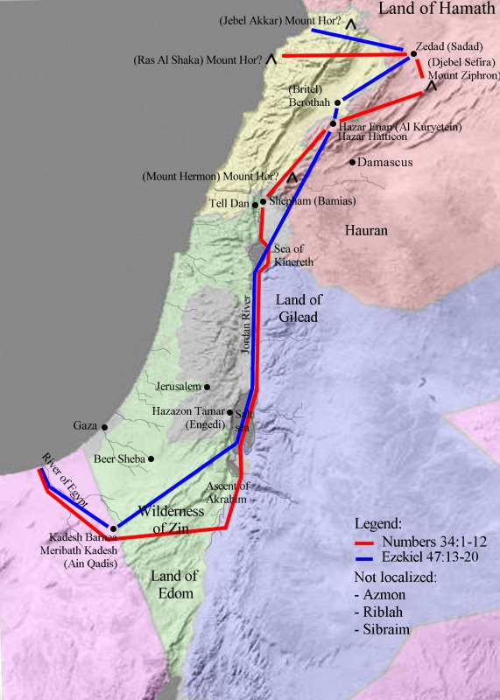
Map showing the borders of the Promised Land, based on Bible. (Genesis 15)
https://en.wikipedia.org/wiki/Promised_Land

David's Officials (8:15-18)
- 2 Sam. 8:15–18 This is a list of David’s officials (for similar lists, cf. 20:23–26; 1 Kings 4:1–6). Like the list in Kings, this one starts with the office of the king. It was the task of the king to establish justice and equity (see 1 Kings 10:9). Jehoshaphat the son of Ahilud appears as recorder in all three lists. The offices of “recorder” and “secretary” (2 Sam. 8:17) were common in surrounding countries. Jerusalem, like other city-states of the time, had a long history of civil administration, which David could take over and use. ESV Study Bible.
- 2 Sam. 8:18 The Cherethites and Pelethites were foreigners who made up the king’s bodyguard (cf. 1 Sam. 28:2). David’s sons were priests. It is not known what their duties were, but obviously their duties were not important compared to those of the Levitical priests Zadok, Abiathar, and Ahimelech, who were concerned with the ark (2 Sam. 15:24); the other lists do not mention David’s sons in this capacity. ESV Study Bible.
  - For David’s role as a priest, please see 2 Samuel 6:14, 18.
- Discussion
  - What are special about David’s officials as compared with today’s government structures? How about for future generations?

David's Kindness to Mephibosheth (9:1-13)
- 2 Sam. 9:1–13 Mephibosheth. David keeps his promise to Jonathan and Saul that he would not destroy their descendants (1 Sam. 20:14–17, 42; 24:21–22) as often happened in changes of dynasty (cf. 2 Kings 10; 11; etc.). ESV Study Bible.
  - 1 Sam. 20:14–17. Jonathan said to David, “.. If I am still alive, show me the steadfast love of the Lord, that I may not die; and do not cut off your steadfast love from my house forever, when the Lord cuts off every one of the enemies of David from the face of the earth.” And Jonathan made a covenant with the house of David, saying, “May the Lord take vengeance on David's enemies.” And Jonathan made David swear again by his love for him, for he loved him as he loved his own soul.
  - Mephibosheth. See 2 Sam. 4:4. Jonathan, the son of Saul, had a son who was crippled in his feet. He was five years old when the news about Saul and Jonathan came from Jezreel, and his nurse took him up and fled, and as she fled in her haste, he fell and became lame. And his name was Mephibosheth.
- 2 Sam. 9:12 Mica (or “Micah”) had many descendants, through whom the house of Saul and Jonathan was preserved (1 Chron. 8:35–40; 9:41–44). ESV Study Bible.
- Discussion
  - Why did David treat Mephibosheth so kindly?

Wrapping up
- What is God’s plan on us as a group? As an individual? How should we respond to them?
- What are your favorite verses?

Peter Luh, David Tai, Chunlong Liu, Mu-Ping Nieh and Abby Lau, 5/31/2018
Copyright UCBSG, UConn Chinese Bible Study Group, 2018

