2 Samuel 4-5. The end of Ish-Bosheth and the City of David, 5/11/2018

Opening
- Jerusalem is top news today. How much do you know about the city?
  - The sacrifice of Isaac by Abraham: the land of Moriah, Genesis 22:2-14.
  - 2 Chronicle 3:1. Then Solomon began to build the house of the Lord in Jerusalem on Mount Moriah, where the Lord had appeared to David his father, at the place that David had appointed, on the threshing floor of Ornan the Jebusite (1Ch 21:28).
  - What are the geographical characteristics of the city of Jerusalem?
  - How and when did David become the King of Judah and Israel?

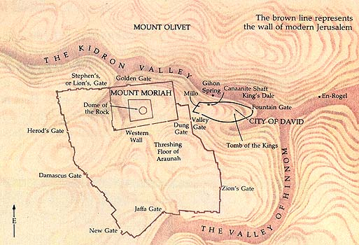

- What are your strongest points? Weakest points (no need to tell others)?
  - What are the strongest points for David? Weakest points?
  - How many wives and concubines did he have? Why? By nature, by position, or for political expedience? What happened to David later on?
  - How about Solomon?
- When is the most likely time for a person to make subtle but fundamental mistakes?
  - When he/she is successful.
  - What is the story of Yin and Yang (阴与阳)?
- Do you remember what we discussed last Friday? Abner joins David. Joab murders Abner and David mourns Abner.

Outline (ESV Study Bible)
- Story of King David (1:1–20:26)
  - David and the death of Saul (1:1–27)
  - David becomes king (2:1–5:5)
  - Jerusalem, the city of David (5:6–25)
  - Zion, the place of worship (6:1–23)
  - Davidic covenant: eternal throne (7:1–29)
  - Catalog of David’s military activities (8:1–18)
  - Mephibosheth (9:1–13)
  - Israel-Ammon war (10:1–12:31)
    - Beginning of Israel-Ammon war (10:1–19)
    - David and Bathsheba (11:1–12:25)
    - End of Israel-Ammon war (12:26–31)
  - Absalom’s banishment and reinstatement (13:1–14:33)
  - Absalom’s rebellion (15:1–19:43)
    - Absalom’s conspiracy (15:1–12)
    - David’s escape from Absalom (15:13–16:14)
    - Ahithophel and Hushai (16:15–17:23)
    - David arrives at Mahanaim (17:24–29)
    - Death of Absalom (18:1–19:8a)
    - David’s return to Jerusalem (19:8b–43)
  - Sheba’s rebellion (20:1–26)
- Epilogue (21:1–24:25)
  - Famine and the death of Saul’s sons (21:1–14)
  - Philistine wars (21:15–22)
  - Song of David (22:1–51)
  - Last words of David (23:1–7)
  - David’s heroes (23:8–39)
  - The census and the threshing floor (24:1–25)

Ish-bosheth Murdered (4)
- 2 Sam. 4:2–3 This passage stresses that those who killed Ish-bosheth were not partisans of David but were from Saul’s own tribe. ESV Study Bible.
  - Beeroth is about 2 miles south of Gibeon and is one of the cities, led by Gibeon, that tricked Joshua into making a treaty with them (Josh. 9:17). The Beerothites had probably fled to Gittaim (which according to Neh. 11:33 was a city in Benjamin) at the time Saul put the Gibeonites to death (see 2 Sam. 21:1). Apparently after that the Benjaminites, including Rimmon and his family, came to live there. ESV Study Bible.
- 2 Sam. 4:4 The information about Mephibosheth is probably put here to show why there was no move to make him king after Ish-bosheth’s death – he was still a child, and he was crippled. He is further mentioned in 9:1–13; 16:1–4; 19:24–29; and 21:7. ESV Study Bible.
- Discussion
  - After the death of Abner, what happened? Why? Is this natural in terms of human nature, including what Rechab and Baanah did?
  - What do you think about David’s decisions on Rechab and Baanah?

David Anointed King of Israel (5:1-16)
- 2 Sam. 5:1–25 It is not clear how soon the events of ch. 5 followed those of ch. 4. Presumably the deaths of Abner and Ish-bosheth caused a shock among David’s supporters in the north (3:19) and caused them to put off accepting David as king. Some of the shock seems to have remained at the time this account was written. David apparently just bided his time, waiting for the elders of Israel to decide that they wanted him as king. ESV Study Bible.
- 2 Sam. 2
  - 1 Sam. 16:1. The Lord said to Samuel, “How long will you grieve over Saul, since I have rejected him from being king over Israel? Fill your horn with oil, and go. I will send you to Jesse the Bethlehemite, for I have provided for myself a king among his sons.”
  - 1 Sam. 16:13. Then Samuel took the horn of oil and anointed him in the midst of his brothers. And the Spirit of the Lord rushed upon David from that day forward. And Samuel rose up and went to Ramah.
  - 1 Sam. 24:20. And now, behold, I know that you shall surely be king, and that the kingdom of Israel shall be established in your hand.
- 2 Sam. 5:6–13 The account of David’s kingship over Israel starts with the capture of Jerusalem, on the boundary between Judah and Benjamin.
  - It had not been controlled by any tribe, and thus it was both symbolically and geographically better suited to be the capital of all Israel than Hebron (in central Judah).
  - Jerusalem was the “Salem” of Melchizedek (Gen. 14:18). It has been fortified since the Middle Bronze Age, i.e., the first half of the second millennium B.C. In the second half of the millennium it was one of the city-states of Canaan that was under the influence of Egypt.
  - The Jebusites are listed among the Canaanites in Gen. 10:16 and, broadly speaking, were considered to be among the Amorites (Josh. 10:5). The city was too strong to be conquered at the time of Joshua (Josh. 15:63; Judg. 1:21).
  - The Jebusite city, the stronghold of Zion, was located on the western slope of the Kidron Valley above the city’s water source, the spring of Gihon. An extensive network of water tunnels has been excavated, one of which was probably the water shaft through which David’s men entered the city. This water shaft is often identified with “Warren’s Shaft,” which is directly over the water channel near the spring, though recent archaeological finds have challenged this. According to 1 Chron. 11:6, Joab led the attack and was therefore made David’s chief commander. ESV Study Bible.
- A few relevant verses:
  - Gen. 14:18. And Melchizedek king of Salem brought out bread and wine. (He was priest of God Most High.)
  - Josh. 10:5. Then the five kings of the Amorites, the king of Jerusalem, the king of Hebron, the king of Jarmuth, the king of Lachish, and the king of Eglon, gathered their forces and went up with all their armies and encamped against Gibeon and made war against it.
  - Josh. 15:63. But the Jebusites, the inhabitants of Jerusalem, the people of Judah could not drive out, so the Jebusites dwell with the people of Judah at Jerusalem to this day.
  - Judg. 1:21. But the people of Benjamin did not drive out the Jebusites who lived in Jerusalem, so the Jebusites have lived with the people of Benjamin in Jerusalem to this day.
  - 1 Chron. 11:6. David said, “Whoever strikes the Jebusites first shall be chief and commander.” And Joab the son of Zeruiah went up first, so he became chief.
- 2 Sam. 5:9 the Millo. Cf. 1 Kings 9:15, 24; 11:27; 1 Chron. 11:8; 2 Chron. 32:5. The Hebrew word means “the fill.” It was a series of terrace walls, built on a steep slope, supporting the fill behind it in order to create level areas. Houses were then built on these artificial platforms, which were connected by narrow staircases. ESV Study Bible.
- 2 Sam. 5:13–14 This is a summary statement about David’s kingship in Jerusalem (cf. 3:2–5); it does not mean that these sons were all born before 5:17. The birth of Solomon is mentioned in 12:24. None of the other sons play a major role in the Samuel–Kings narratives. Nathan (2 Sam. 5:14) was an ancestor of Jesus (Luke 3:31), as was Solomon (Matt. 1:6–7).
- Discussion
  - “You will not come in here, but the blind and the lame will ward you off” – thinking, “David cannot come in here.” Why did Jebusites say such things?
  - Verse 5:12 is very moving. However, why did David took more concubines and wives right in the next verse 5:13?
  - How about our own behaviors?

David Defeats the Philistines (5:17-25)
- 2 Sam. 5:17–21 Until now the Philistines may have considered that David was to some extent still their vassal (1 Samuel 27); at least they must have been happy about his struggle with Ish-bosheth. But when David becomes king over Israel (i.e., both Israel and Judah) and even captures Jerusalem, they realize that he is a threat. The Philistines left their idols there (5:21) is a reversal of 1 Samuel 4, where the Philistines carried off the ark of the covenant. According to 1 Chron. 14:12, David had the idols burned. ESV Study Bible.
  - 1 Chron. 14:12. And they left their gods there, and David gave command, and they were burned.

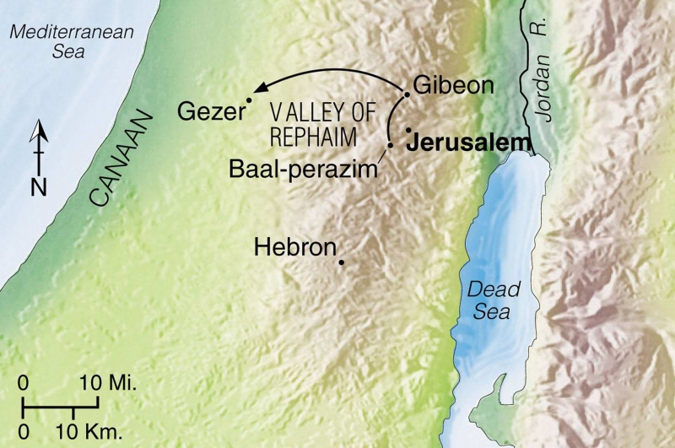

- 2 Sam. 5:22–25 It may be that the sound of marching was a distinct sound caused by the Lord that frightened the Philistines (as in 2 Kings 7:6). Another possibility is that the Philistines knew the sound was the sound of trees, so David was able to use the sound as cover for his attack. By this victory, David drove the Philistines out of the central hill country. ESV Study Bible.
- Discussion
  - Can we see that David followed the will of God here? Implications to our lives today?

Wrapping up
- 2 Sam. 5:12. David knew that the Lord had established him king over Israel, and that he had exalted his kingdom for the sake of his people Israel.
  - What do we know about ourselves? How to avoid major mistake when we think that we are doing fine?
- What are your favorite verses?

Peter Luh, David Tai, Mu-Ping Nieh, Chunlong Liu and Yue Wang, 5/8/2018
Copyright UCBSG, UConn Chinese Bible Study Group, 2018

