2 Samuel 24. David’s Praises to the Lord, 8/24/2018

Opening
- Have you ever participated in a census? How was that done? What was that for?
  - In the era of “Big Data” and “Data Science,” is census important? Why or why not?
  - There was a famous census recorded in the New Testimony. Can you name that? What was that for? Why was that important?
- Have you disciplined your children? How do you do that? Do you give them several punishment options? Would you let others discipline your children for you?
  - Have you been disciplined by your parents? What was your experience?
  - If you had a choice of selecting one punishment among several, what was your criteria of selection?
  - How about your preferences in today’s settings when you face several unpleasant options?
- Can we offer things belonging to others to God?
- Do you remember what we discussed last Friday? David describes God and his own situation. The Lord’s response to David’s call. What David has done with the support of the Lord. What happened next? Great joy turns to sorrow (樂極生悲)?

Outline (ESV Study Bible)
- Story of King David (1:1–20:26)
  - David and the death of Saul (1:1–27)
  - David becomes king (2:1–5:5)
  - Jerusalem, the city of David (5:6–25)
  - Zion, the place of worship (6:1–23)
  - Davidic covenant: eternal throne (7:1–29)
  - Catalog of David’s military activities (8:1–18)
  - Mephibosheth (9:1–13)
  - Israel-Ammon war (10:1–12:31)
    - Beginning of Israel-Ammon war (10:1–19)
    - David and Bathsheba (11:1–12:25)
    - End of Israel-Ammon war (12:26–31)
  - Absalom’s banishment and reinstatement (13:1–14:33)
  - Absalom’s rebellion (15:1–19:43)
    - Absalom’s conspiracy (15:1–12)
    - David’s escape from Absalom (15:13–16:14)
    - Ahithophel and Hushai (16:15–17:23)
    - David arrives at Mahanaim (17:24–29)
    - Death of Absalom (18:1–19:8a)
    - David’s return to Jerusalem (19:8b–43)
  - Sheba’s rebellion (20:1–26)
- Epilogue (21:1–24:25)
  - Famine and the death of Saul’s sons (21:1–14)
  - Philistine wars (21:15–22)
  - Song of David (22:1–51)
  - Last words of David (23:1–7)
  - David’s heroes (23:8–39)
  - The census and the threshing floor (24:1–25)
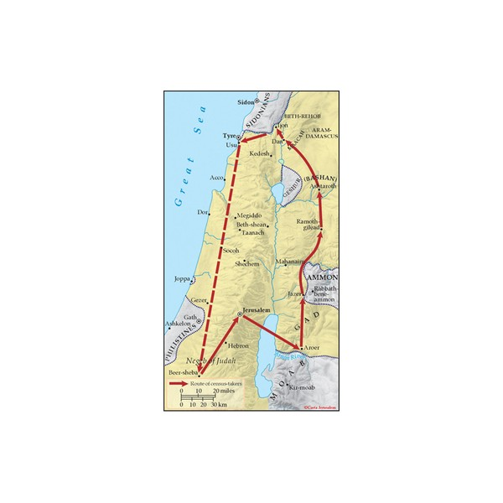http://store.carta-jerusalem.com/carta-map-bank/215-joab-s-census.html

David’s Census (24:1-9)
- What was the purpose of the census talked about here?
- 2 Sam. 24:1–25 The Census and the Threshing Floor. The Lord’s anger and David’s sin lead to a plague, but also to the purchase of a site in Jerusalem to offer burnt offerings to the Lord. ESV Study Bible.
- 2 Sam. 24:1 Here the text says, the Lord … incited David, while 1 Chron. 21:1 reads, “Satan … incited David.” The Lord allowed Satan to incite David. God himself never does evil, but sometimes he uses evil moral agents (demons and sinful human beings) to accomplish his purposes. ESV Study Bible.
  - 1 Chron. 21:1. Then Satan stood against Israel and incited David to number Israel.
- 2 Sam. 24:3 By numbering the people for military purposes (v. 9), David apparently showed lack of trust in the Lord to supply the necessary men when needed, and wrongful pride in the hundreds of thousands of forces at his command (see v. 10). Joab knew it was wrong. Exodus 30:12 has a reference to the need for a “ransom” after the counting. ESV Study Bible.
  - Exodus 30:12. The Lord said to Moses, “When you take the census of the people of Israel, then each shall give a ransom for his life to the Lord when you number them, that there be no plague among them when you number them.
- Discussion
  - What was the purpose of David’s census?
  - Today we live in a world with many of our true intentions hidden deep down somewhere. When we decide to do something, do we know our true intensions? Are they pleasing to God?

The Lord's Judgment of David's Sin (24:10-17)
- 2 Sam. 24:10 David’s heart struck him. His conscience convicted him that his census was sin. ESV Study Bible.
- 2 Sam. 24:13 Famine, sword, and pestilence is a well-known trio of disasters (Jer. 14:12; 18:21; Ezek. 5:17; etc.). Probably the number of people who would die in each of these disasters would be approximately equal; pestilence kills faster (three days’) than famine (“three years”). ESV Study Bible.
- 2 Sam. 24:17 Behold, I have sinned. … But these sheep, what have they done? David pleads that the people may not suffer for his sin, but he is the representative of God’s people, and thus they bear the consequences of his behavior, whether good or evil. ESV Study Bible.
  - Please let your hand be against me. David offers personally to bear the punishment for this sin, but God does not accept the offer. This is, however, a worthy gesture on David’s part, and sets the pattern for his ultimate descendant, the Messiah, who will bear the punishment due his people. ESV Study Bible.
- Discussion
  - If you were David, what would be your choice?
  - How about your preferences in today’s settings when you face several unpleasant options?

David Builds an Altar (24:18-25)
- 2 Sam. 24:20 Araunah looked down. Threshing floors were usually on a high place so that the wind could blow the chaff away. ESV Study Bible.
- 2 Sam. 24:25 God accepted David’s burnt offerings, and through the peace offerings David enjoyed the presence of the Lord. Thus God responded to the plea for the land. But this site will become much more significant in the future, for as the parallel account (in 1 Chron. 22:1) states, this threshing floor is the site on which Solomon would build the temple to the Lord – making this a fitting end to the story of David. ESV Study Bible.
- Discussion
  - What do you think about 2 Samuel? What is the most important thing that you learned or you liked?

Wrapping up
- What are your favorite verses in Chapter 24?

Peter Luh, Chunlong Liu, Abby Lau, David Tai, and Mu-Ping Nieh, 8/23/2018
Copyright UCBSG, UConn Chinese Bible Study Group, 2018

