2 Samuel 10. Victory over Ammonites and Arameans, 6/8/2018

Opening
- Divorce rates are relatively high in the US, China and many other places. Some people divorce for justifiable reasons. Many divorces, however, were triggered by trivial issues. Right? Why?
  - How about your recent fights with your spouse and girlfriend/boyfriend?
  - How about relationships between countries? Good hearts and thoughts be misinterpreted? Can a war get started via trivial issues?
  - How to fight a war and win?
  - From the above, what can we learn to better manage our daily lives?
- How to humiliate someone?
  - How to handle humiliation?
- Do you remember what we discussed last Friday? David's Victories. David's Officials. David's Kindness to Mephibosheth.

Outline (ESV Study Bible)
- Story of King David (1:1–20:26)
  - David and the death of Saul (1:1–27)
  - David becomes king (2:1–5:5)
  - Jerusalem, the city of David (5:6–25)
  - Zion, the place of worship (6:1–23)
  - Davidic covenant: eternal throne (7:1–29)
  - Catalog of David’s military activities (8:1–18)
  - Mephibosheth (9:1–13)
  - Israel-Ammon war (10:1–12:31)
    - Beginning of Israel-Ammon war (10:1–19)
    - David and Bathsheba (11:1–12:25)
    - End of Israel-Ammon war (12:26–31)
  - Absalom’s banishment and reinstatement (13:1–14:33)
  - Absalom’s rebellion (15:1–19:43)
    - Absalom’s conspiracy (15:1–12)
    - David’s escape from Absalom (15:13–16:14)
    - Ahithophel and Hushai (16:15–17:23)
    - David arrives at Mahanaim (17:24–29)
    - Death of Absalom (18:1–19:8a)
    - David’s return to Jerusalem (19:8b–43)
  - Sheba’s rebellion (20:1–26)
- Epilogue (21:1–24:25)
  - Famine and the death of Saul’s sons (21:1–14)
  - Philistine wars (21:15–22)
  - Song of David (22:1–51)
  - Last words of David (23:1–7)
  - David’s heroes (23:8–39)
  - The census and the threshing floor (24:1–25)

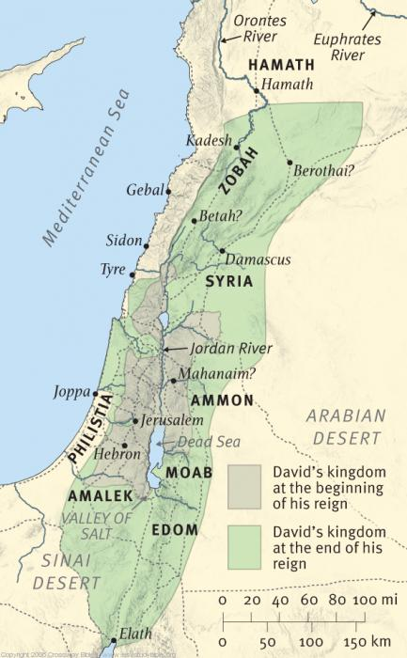
Geographical setting of 2 Samuel. ESV Study Bible

David Defeats Ammon and Syria (10:1-19)
- 2 Sam. 10:1–12:31 Israel-Ammon War. The Ammonite war is the background of the next three chapters. As far as David’s empire went, it led to his domination of the Syrian kingdoms (see 8:3–12; 10:15–19). More importantly to the biblical writer, however, it was the setting for David’s great sin (11:1–12:25). ESV Study Bible.
- 2 Sam. 10:1–19 Beginning of Israel-Ammon War. The war began because the Ammonites disgraced David’s ambassadors; it did not result from any wrongdoing by David. ESV Study Bible.
  - How could a war be triggered by such an issue?
  - What was David’s role in the starting of the war?
- 2 Sam. 5 Why did David tell his servants “Remain at Jericho until your beards have grown and then return”? Was that a wise decision?
- 2 Sam. 10:6–8 Beth-rehob, Zobah, Maacah, and Tob were Syrian kingdoms in the northern Transjordan and Lebanon Valley. Hiring armies was not uncommon (2 Kings 7:6). Syrians can also be translated “Aram” or “Arameans,” the normal term for Syria or the Syrians. “Aramaic,” the later common language, was the language of Syria. ESV Study Bible.
  - The gate (2 Sam. 10:8) is that of the city of Rabbah (11:1), the capital of Ammon, near present-day Amman, Jordan. ESV Study Bible.
- 2 Sam. 10:9–19 David’s army under Joab is trapped between the Syrians and the Ammonites, but they defeat the Syrians and force them to leave. Hadadezer of Zobah attacks again at Helam, apparently a city in northern Transjordan, but is again defeated. ESV Study Bible.
- 2 Sam. 10:9-14 How did Joab fight the war? Can you please summarize that? What can be learned?
  - Worked with his brother Abishai in mutually supportive roles.
  - Treated Syrians and Ammonites separately.
  - Had a great prioritization with a concentrated force at the very beginning – fully understanding the domino effects.
  - Had a nice pep talk.
  - Trusted in God.
- 2 Sam. 10:12 Let us be courageous … and may the Lord do what seems good to him. Joab expresses both faith in God and a resolve to fight with all his strength. Faith and human effort are not incompatible with each other. ESV Study Bible.
  - Joab is a complicated figure: as here, he can express sturdy piety (e.g., 24:3), and he can also display a chilling ruthlessness in preserving David’s and his own position (e.g., 18:14–15; 20:9–10, 20–22). It is not surprising that David does not trust him to treat Solomon well after Joab supported Adonijah (1 Kings 1:7, 19; 2:5–6). ESV Study Bible.
- Discussion

Wrapping up
- How should we deal with trivial as well as complicated issues? How to be wise?
- What are your favorite verses?

Peter Luh, David Tai and Chunlong Liu, 6/6/2018
Copyright UCBSG, UConn Chinese Bible Study Group, 2018

